Project Design Phase-II
Data Flow Diagram & User Stories

Date | 10 Febraury 2026
Team ID | LTVIP2026TMIDS76292
Project Name | Laptop Request Catalog Item
Maximum Marks | 4 Marks

Data Flow Diagrams:
A Data Flow Diagram (DFD) is a traditional visual representation of the information flows within a system. A neat and clear DFD can depict the right amount of the system requirement graphically. It shows how data enters and leaves the system, what changes the information, and where data is stored.
Example: DFD Level 0 (Industry Standard) 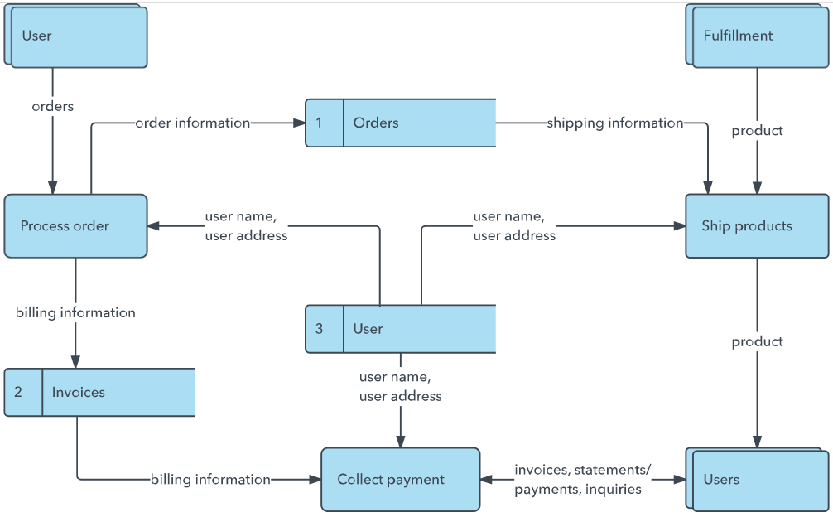
Example: (Simplified)


User Stories
User Type | Functional Requirement (Epic) | User Story Number | User Story / Task | Acceptance criteria | Priority | Release
Employee (Catalog User) | Laptop Request Submission | USN-1 | As an employee, I can submit a laptop request through the Service Catalog. | Laptop request generates REQ number successfully | High | Sprint-1
Employee (Catalog User) | Laptop Model Selection | USN-2 | As an employee, I can select or enter the laptop model while submitting the request. | Selected model is captured in the request record | High | Sprint-1
Employee (Catalog User) | Justification Entry | USN-3 | As an employee, I can provide justification for the laptop request. | Justification field is mandatory before submission | High | Sprint-1
Employee (Catalog User) | Dynamic Accessories Field | USN-4 | As an employee, I can add additional accessories only when required. | Accessories details field appears only when checkbox is selected | High | Sprint-1
Employee (Catalog User) | Form Reset | USN-5 | As an employee, I can reset the form using a UI action. | All entered values are cleared on clicking reset | Medium | Sprint-1
Employee (Catalog User) | Request Tracking | USN-6 | As an employee, I can track the status of my laptop request | Request status shows stages like Approval, In Progress, Completed | High | Sprint-1
IT Approver / Manager | Approval Process | USN-7 | As an approver, I can approve or reject laptop requests. | Approval updates request stage accordingly | High | Sprint-1
IT Fulfillment Team | Task Management | USN-8 | As IT staff, I can view and process laptop request tasks. | Task is created automatically after approval | High | Sprint-1
ServiceNow Administrator | Update Set Management | USN-9 | As IT staff, I can view and process laptop request tasks. | All customizations appear in update set | High | Sprint-1

